WEEK 6:React
File 1. ReactJS-HOL

App.js
import React from 'react';
function App() {
return (
<div>
<h1>Welcome to the first session of React</h1>
</div>
);
}
export default App;

File Structure
myfirstreact/
├── node_modules/
├── public/
├── src/
│ ├── App.js ← Edited file
│ ├── index.js
│ └── ...
├── package.json
└── …

Output:
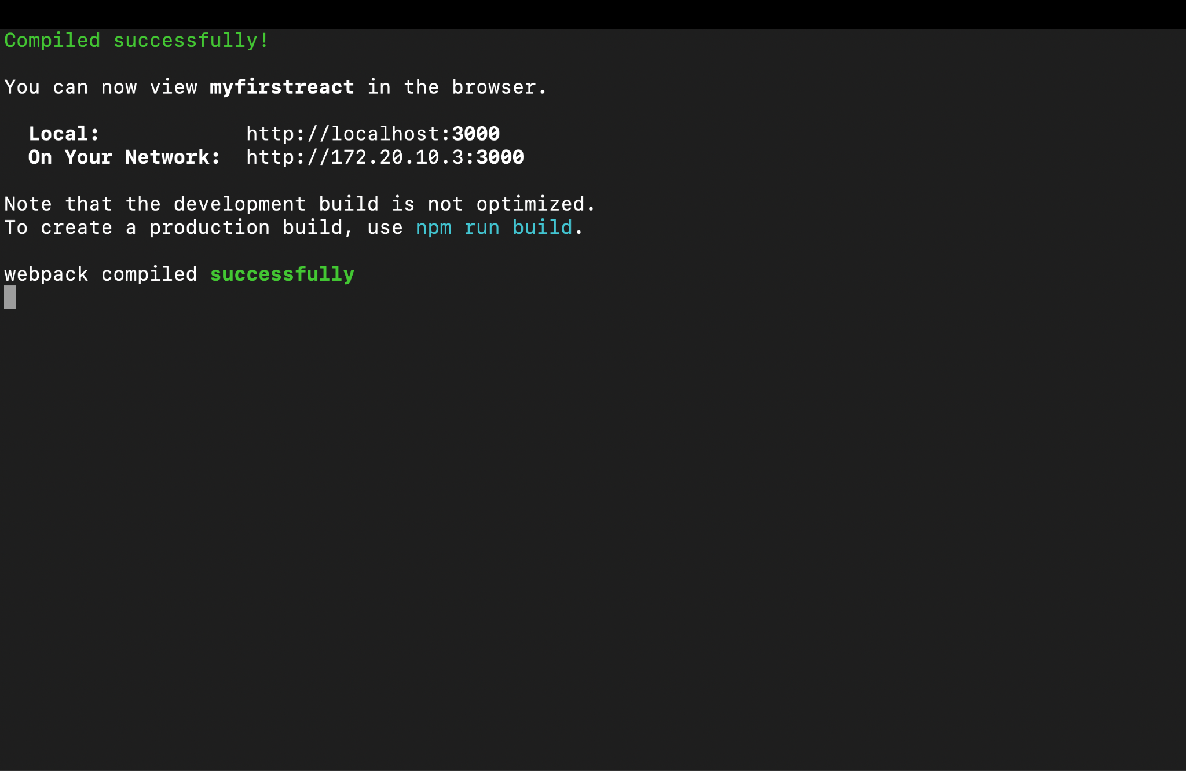

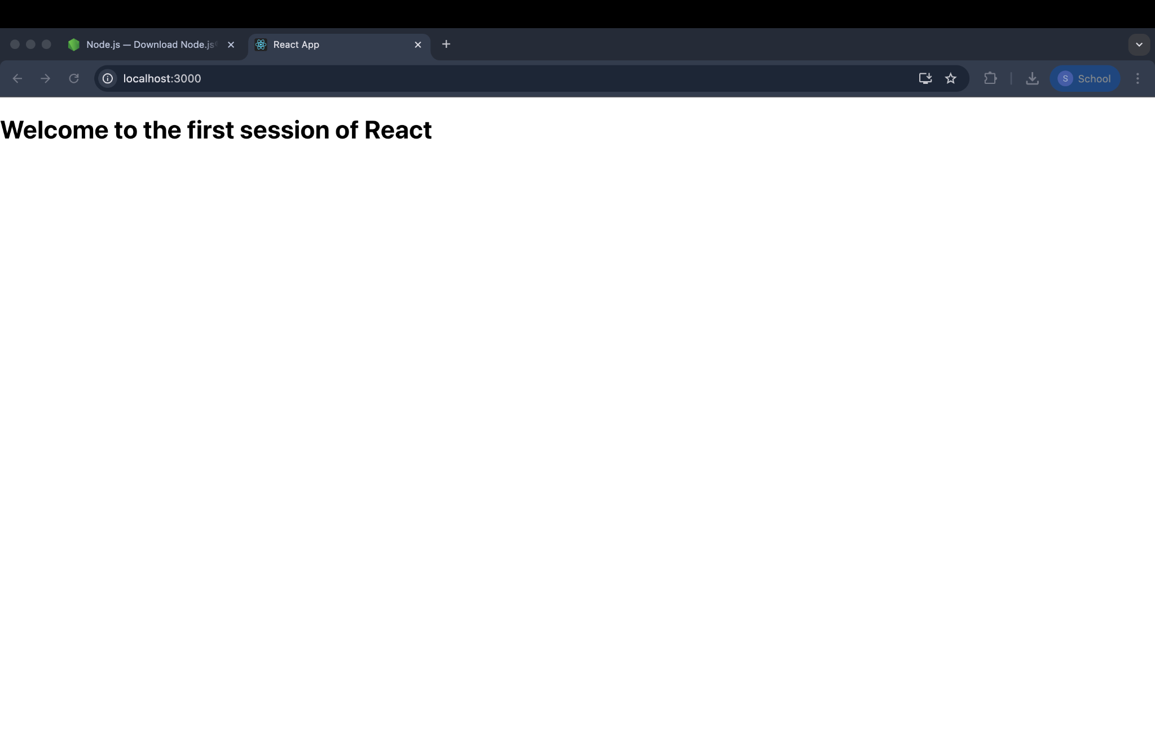

File 2. ReactJS-HOL

import React from 'react';
class Home extends React.Component {
render() {
return (
<div>
<h2>Welcome to the Home page of Student Management Portal</h2>
</div>
);
}
}
export default Home;

import React from 'react';
class About extends React.Component {
render() {
return (
<div>
<h2>Welcome to the About page of the Student Management Portal</h2>
</div>
);
}
}
export default About;

import React from 'react';
class Contact extends React.Component {
render() {
return (
<div>
<h2>Welcome to the Contact page of the Student Management Portal</h2>
</div>
);
}
}
export default Contact;

import React from 'react';
import Home from './Components/Home';
import About from './Components/About';
import Contact from './Components/Contact';

function App() {
return (
<div>
<Home />
<About />
<Contact />
</div>
);
}
export default App;

Output:

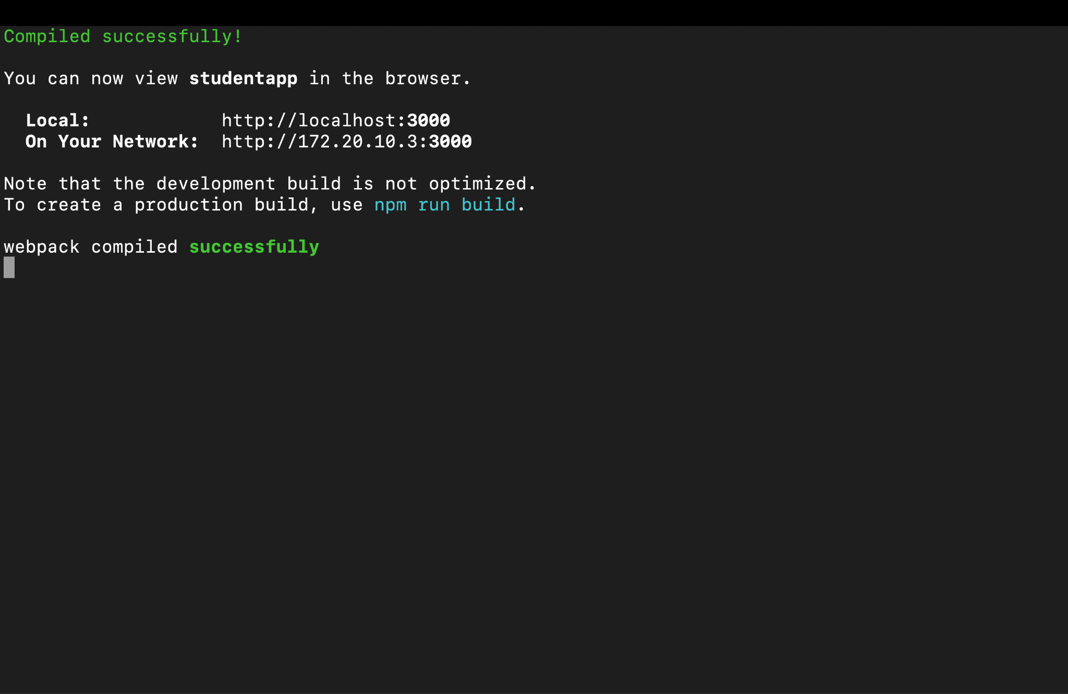

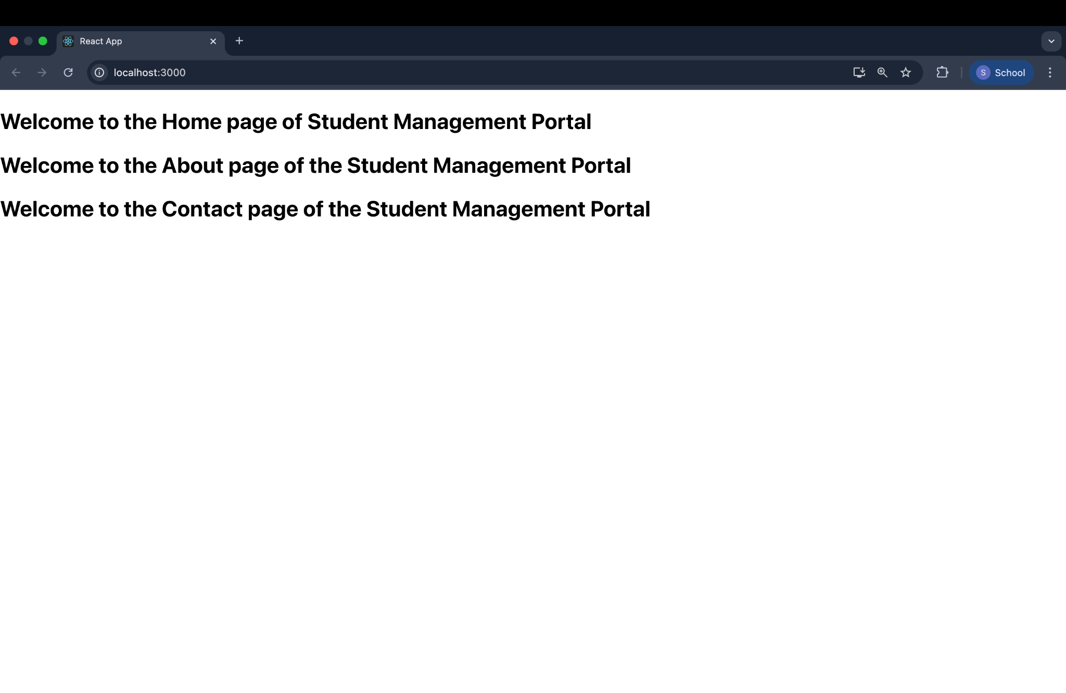

File 3. ReactJS-HOL
CalculateScore.js
import React from 'react';
import '../Stylesheets/mystyle.css';

function CalculateScore(props) {
const average = props.Total / props.Goal;

return (
<div className="score-card">
<h2>Student Score Report</h2>
<p><strong>Name:</strong> {props.Name}</p>
<p><strong>School:</strong> {props.School}</p>
<p><strong>Total Score:</strong> {props.Total}</p>
<p><strong>Number of Goals:</strong> {props.Goal}</p>
<p><strong>Average Score:</strong> {average.toFixed(2)}</p>
</div>
);
}
export default CalculateScore;

mystyle.css
.score-card {
border: 2px solid #4CAF50;
padding: 20px;
margin: 20px auto;
width: 400px;
font-family: Arial, sans-serif;
background-color: #f9f9f9;
border-radius: 10px;
}
.score-card h2 {
text-align: center;
color: #4CAF50;
}

App.js
import React from 'react';
import CalculateScore from './Components/CalculateScore';
function App() {
return (
<div>
<CalculateScore
Name="Keerthi"
School="Sunrise Public School"
Total={450}
Goal={5}
/>
</div>
);
}
export default App;
Output:
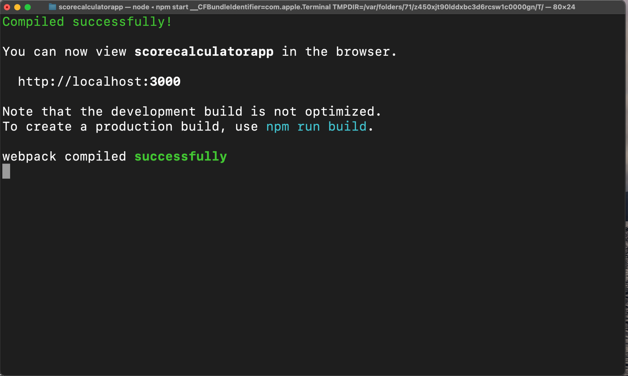
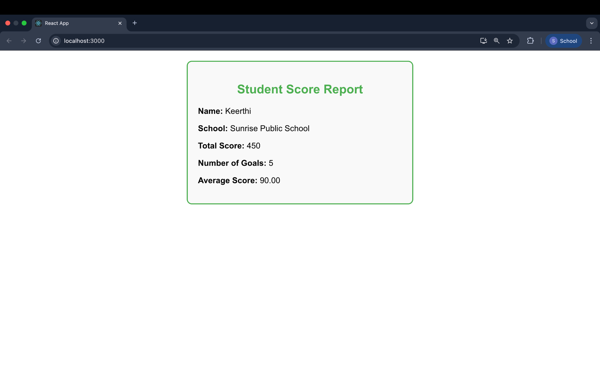

File 4. ReactJS-HOL

Post.js
import React from 'react';
class Post extends React.Component {
render() {
return (
<div className="post">
<h3>{this.props.title}</h3>
<p>{this.props.body}</p>
</div>
);
}
}

Posts.js
export default Post;
import React from 'react';
import Post from './Post';
class Posts extends React.Component {
constructor(props) {
super(props);
this.state = {
posts: [],
hasError: false
};
}

loadPosts = () => {
fetch('https://jsonplaceholder.typicode.com/posts')
.then(response => response.json())
.then(data => this.setState({ posts: data }))
.catch(error => {
this.setState({ hasError: true });
console.error('Error fetching posts:', error);
});
};
componentDidMount() {
this.loadPosts();
}

componentDidCatch(error, info) {
alert("An error occurred in the component.");
console.error("Error boundary caught an error:", error, info);
}

render() {
if (this.state.hasError) {
return <h2>Something went wrong while loading posts.</h2>;
}

return (
<div>
<h1>Blog Posts</h1>
{this.state.posts.map(post => (
<Post key={post.id} title={post.title} body={post.body} />
))}
</div>
);
}
}

App.js
export default Posts;
import React from 'react';
import Posts from './Posts';

function App() {
return (
<div className="App">
<Posts />
</div>
);
}

export default App;

Output:
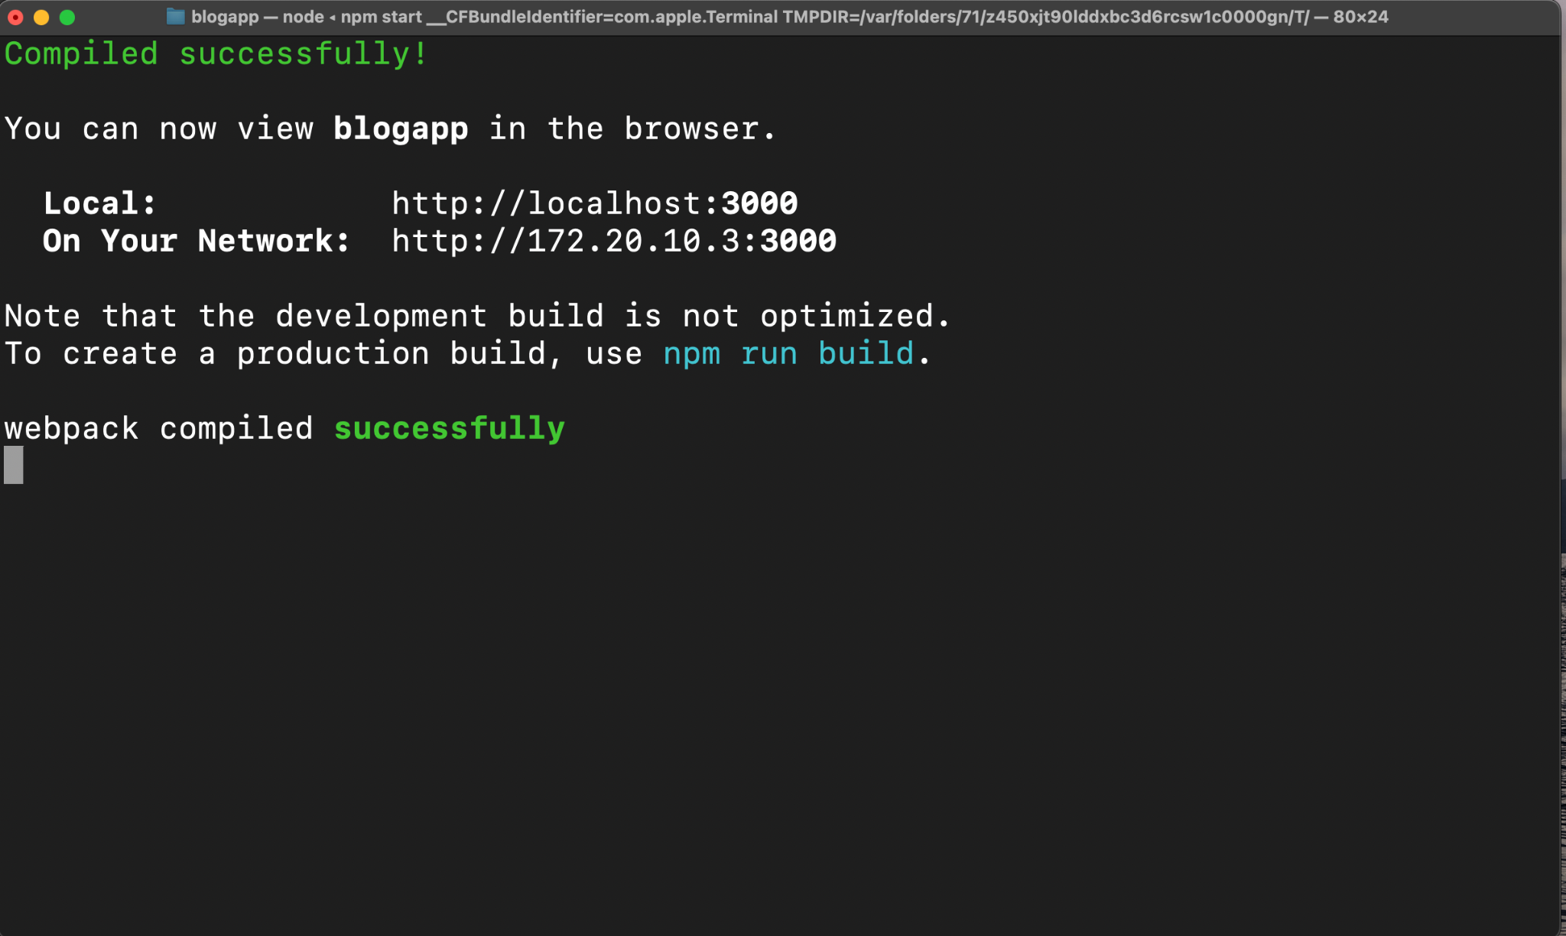
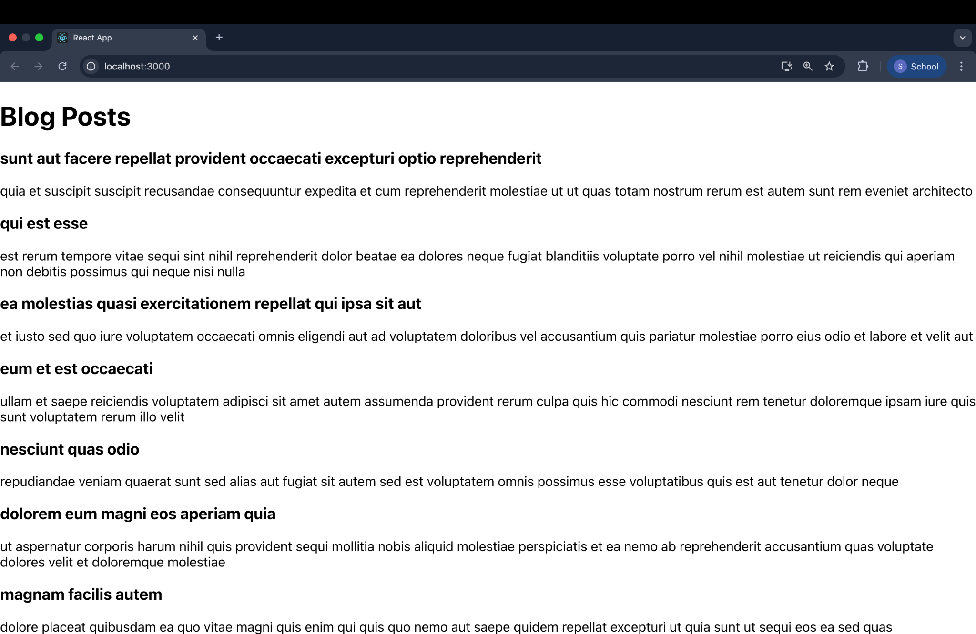

File 5. ReactJS-HOL
.box {
width: 300px;
display: inline-block;
margin: 10px;
padding: 10px 20px;
border: 1px solid black;
border-radius: 10px;
}
dt {
font-weight: 500;
}

// CohortDetails.js
import React from 'react';
import styles from './CohortDetails.module.css';

function CohortDetails({ cohort }) {
const headingStyle = {
color: cohort.status === 'ongoing' ? 'green' : 'blue',
};

return (
<div className={styles.box}>
<h3 style={headingStyle}>{cohort.name}</h3>
<dl>
<dt>Status:</dt>
<dd>{cohort.status}</dd>
<dt>Start Date:</dt>
<dd>{cohort.startDate}</dd>
<dt>End Date:</dt>
<dd>{cohort.endDate}</dd>
</dl>
</div>
);
}

App.js
export default CohortDetails;
import React from 'react';
import CohortDetails from './CohortDetails';

function App() {
const cohorts = [
{
id: 1,
name: 'React Bootcamp',
status: 'ongoing',
startDate: '2025-07-01',
endDate: '2025-07-30',
},
{

id: 2,
name: 'Angular Training',
status: 'completed',
startDate: '2025-05-15',
endDate: '2025-06-15',
}
];

return (
<div style={{ textAlign: 'center' }}>
<h1>My Academy Dashboard</h1>
{cohorts.map(cohort => (
<CohortDetails key={cohort.id} cohort={cohort} />
))}
</div>
);
}

export default App;

Output:
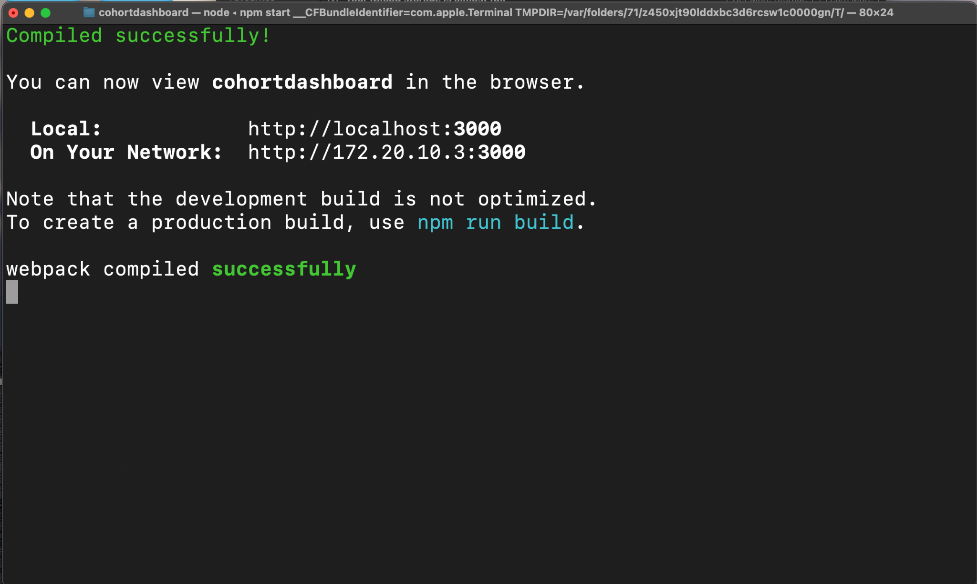

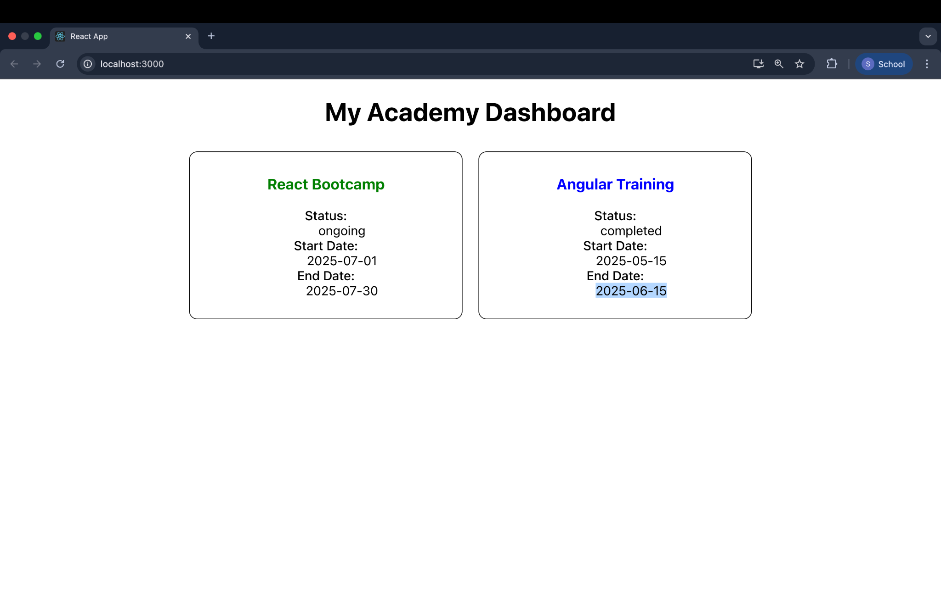
File 6. ReactJS-HOL

class Trainer {
constructor(id, name, email, phone, technology, skills) {
this.TrainerId = id;
this.Name = name;
this.Email = email;
this.Phone = phone;
this.Technology = technology;
this.Skills = skills;
}
}

export default Trainer;
import Trainer from './Trainer';
const trainers = [
new Trainer(1, 'Alice Johnson', 'alice@academy.com', '1234567890', 'React', ['JSX', 'Hooks', 'Redux']),
new Trainer(2, 'Bob Smith', 'bob@academy.com', '2345678901', 'Angular', ['Components', 'RxJS', 'NgRx']),
new Trainer(3, 'Charlie Lee', 'charlie@academy.com', '3456789012', 'Vue', ['Vuex', 'Composition API']),
];

export default trainers;

import React from 'react';

function Home() {
return (
<div>
<h2>Welcome to Cognizant Academy Trainer Portal</h2>
<p>This is a SPA built using React and React Router.</p>
</div>
);
}

TrainersList.js
export default Home;
import React from 'react';
import { Link } from 'react-router-dom';

function TrainersList({ trainers }) {
return (
<div>
<h2>Trainers List</h2>
<ul>
{trainers.map(trainer => (
<li key={trainer.TrainerId}>
<Link to={`/trainer/${trainer.TrainerId}`}>{trainer.Name}</Link>
</li>
))}
</ul>
</div>
);
}

TrainerDetails.js
export default TrainersList;
import React from 'react';
import { useParams } from 'react-router-dom';
import trainers from './TrainersMock';

function TrainerDetails() {
const { id } = useParams();
const trainer = trainers.find(t => t.TrainerId === parseInt(id));

if (!trainer) {
return <p>Trainer not found.</p>;
}

return (
<div>
<h2>{trainer.Name}</h2>
<p><strong>Email:</strong> {trainer.Email}</p>
<p><strong>Phone:</strong> {trainer.Phone}</p>
<p><strong>Technology:</strong> {trainer.Technology}</p>
<p><strong>Skills:</strong> {trainer.Skills.join(', ')}</p>
</div>
);
}

App.js
export default TrainerDetails;
import React from 'react';
import { BrowserRouter as Router, Routes, Route, Link } from 'react-router-dom';
import Home from './Home';
import TrainersList from './TrainersList';
import TrainerDetails from './TrainerDetails';
import trainers from './TrainersMock';

function App() {
return (
<Router>
<div>
<nav style={{ marginBottom: '20px' }}>
<Link to="/" style={{ marginRight: '10px' }}>Home</Link>
<Link to="/trainers">Trainers</Link>
</nav>

<Routes>
<Route path="/" element={<Home />} />
<Route path="/trainers" element={<TrainersList trainers={trainers} />} />
<Route path="/trainer/:id" element={<TrainerDetails />} />
</Routes>
</div>
</Router>
);
}
export default App;
Output:

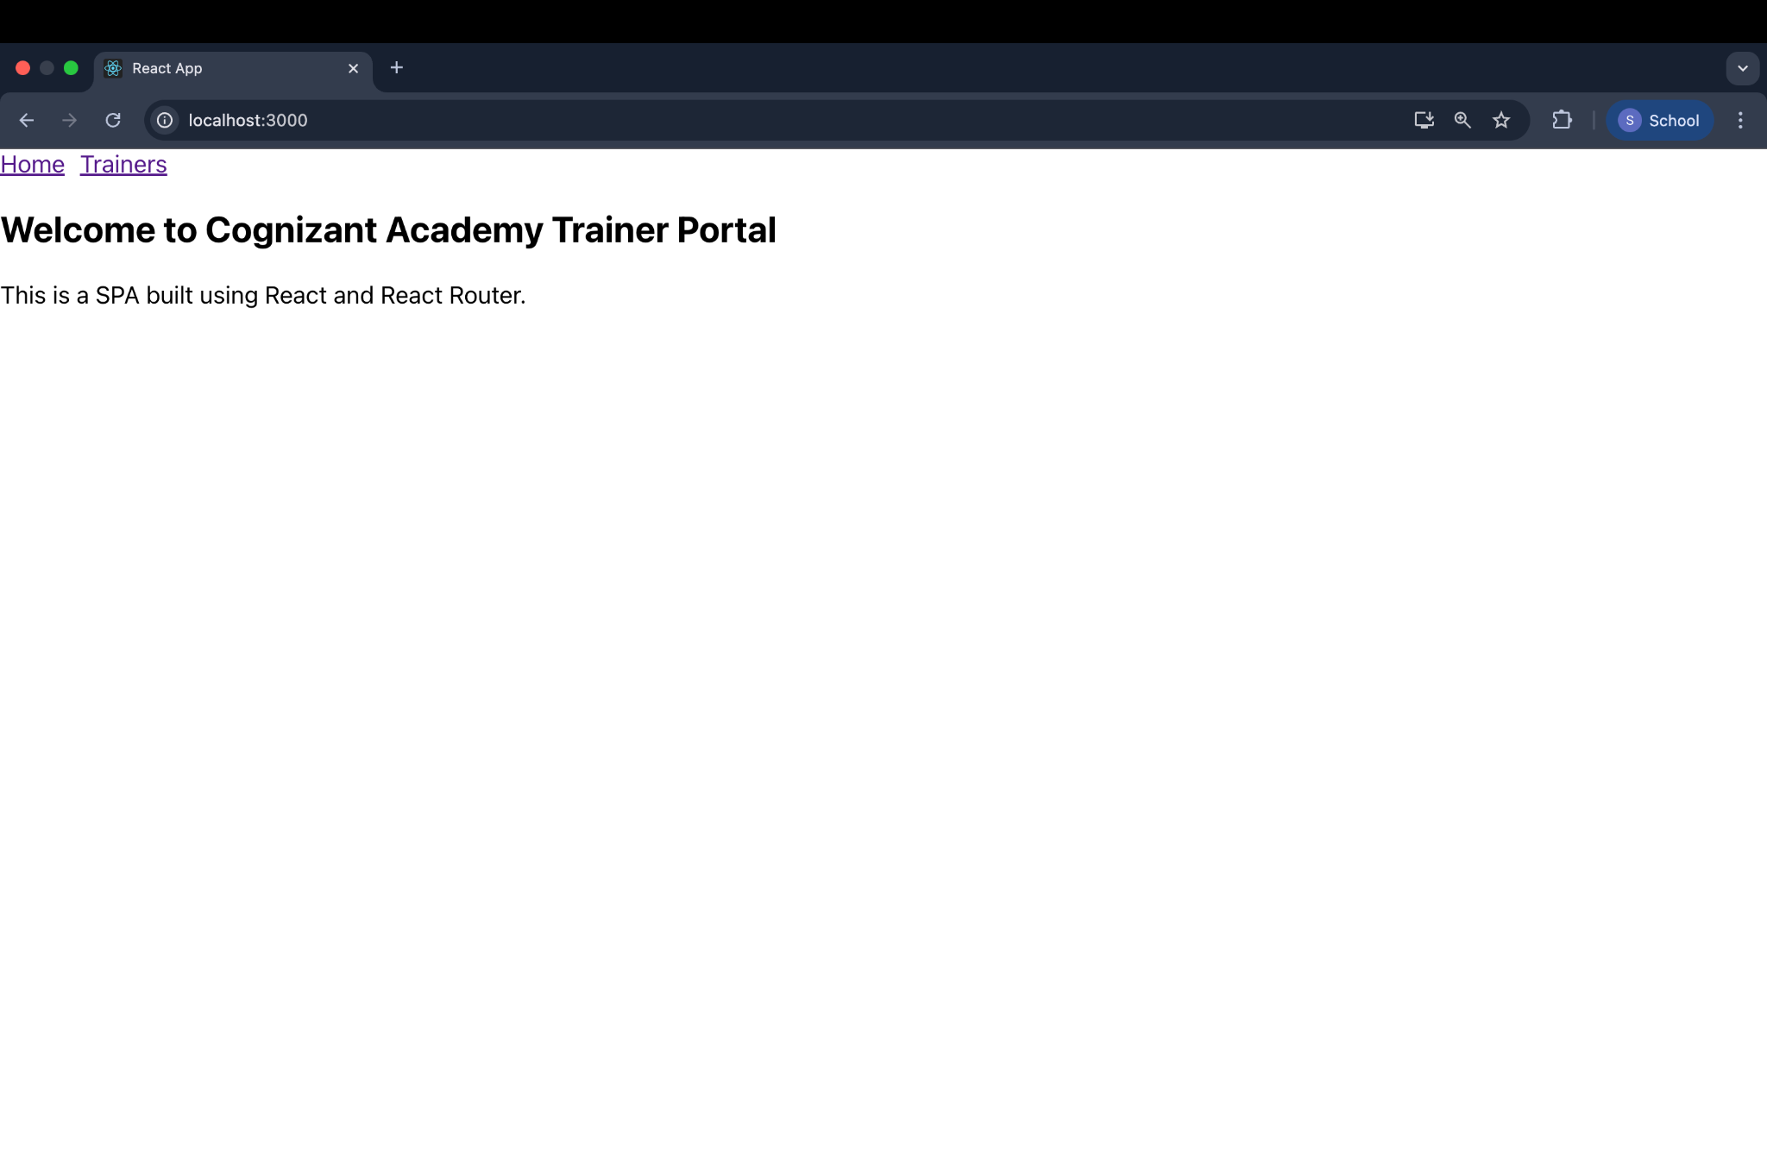
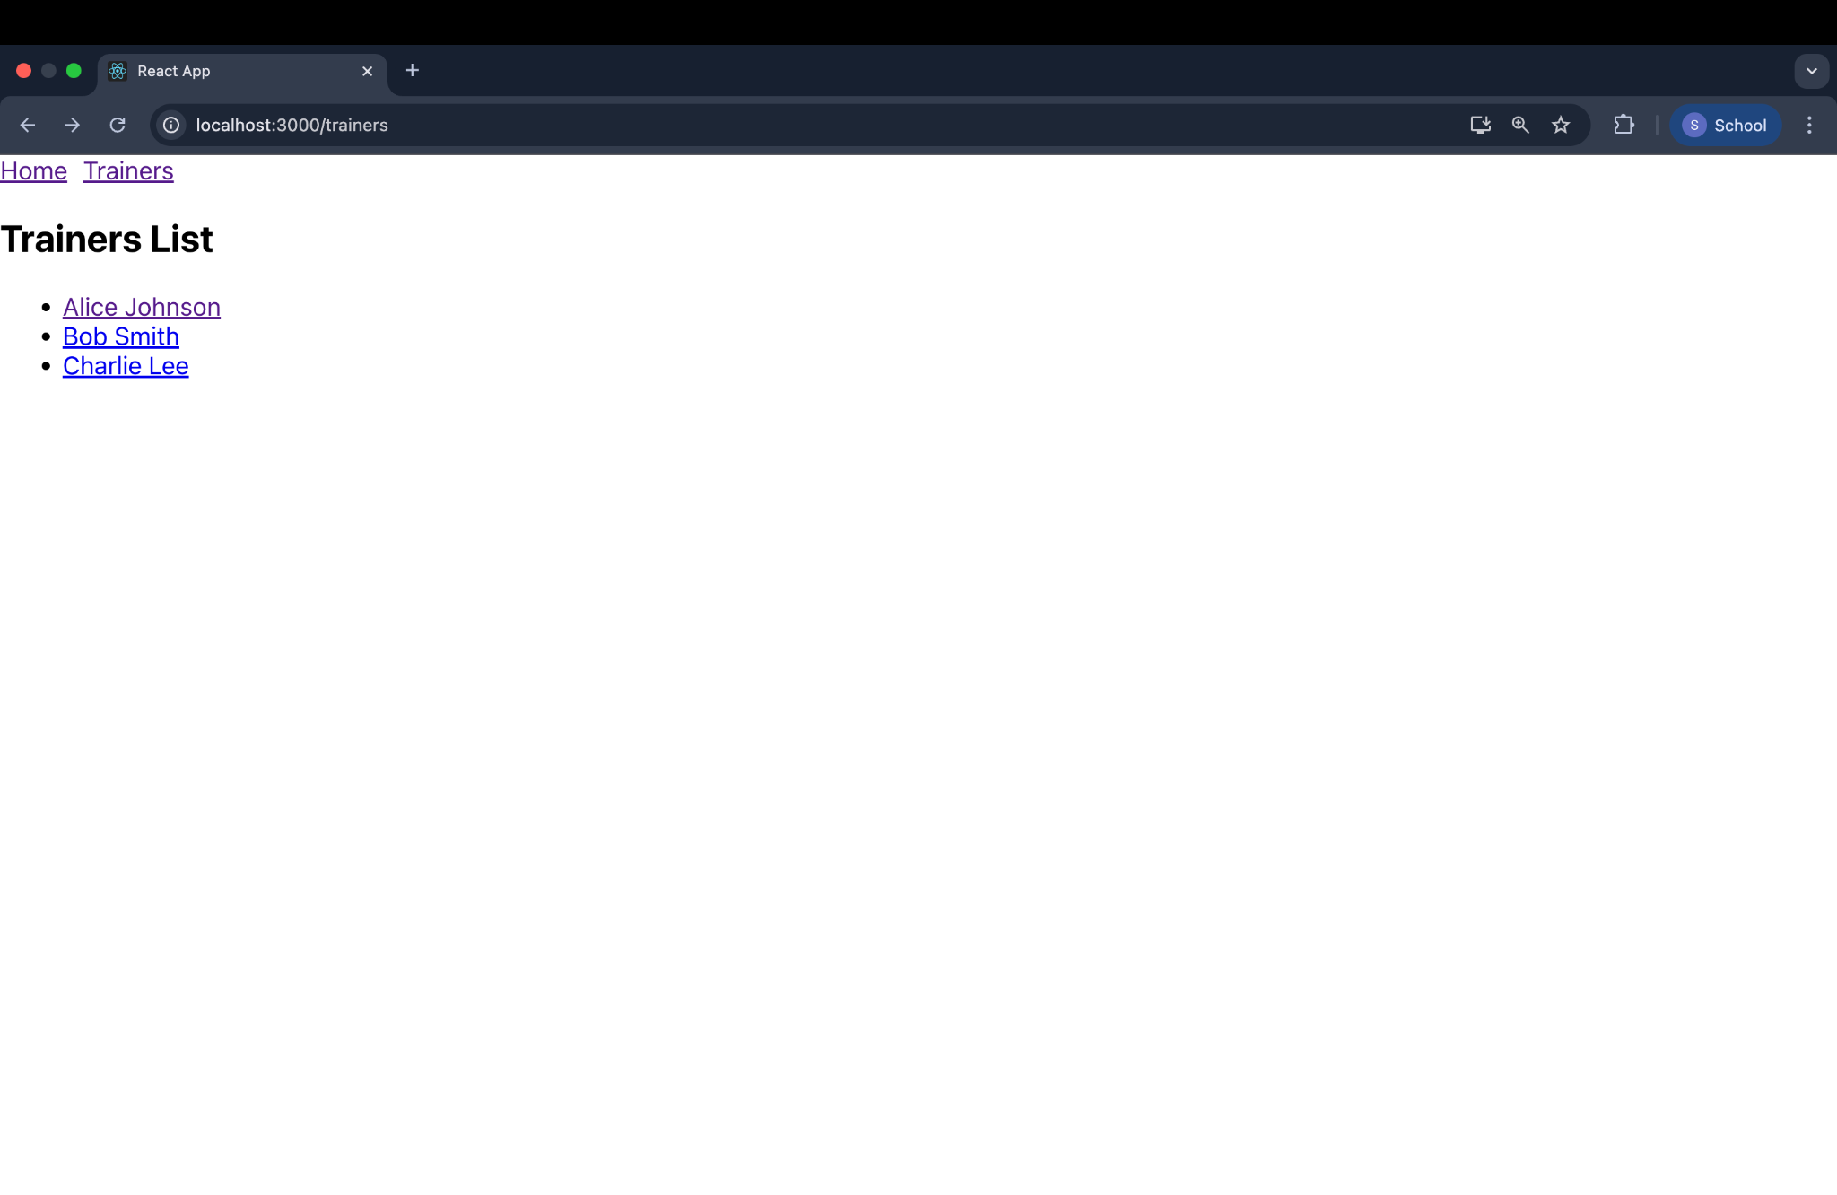

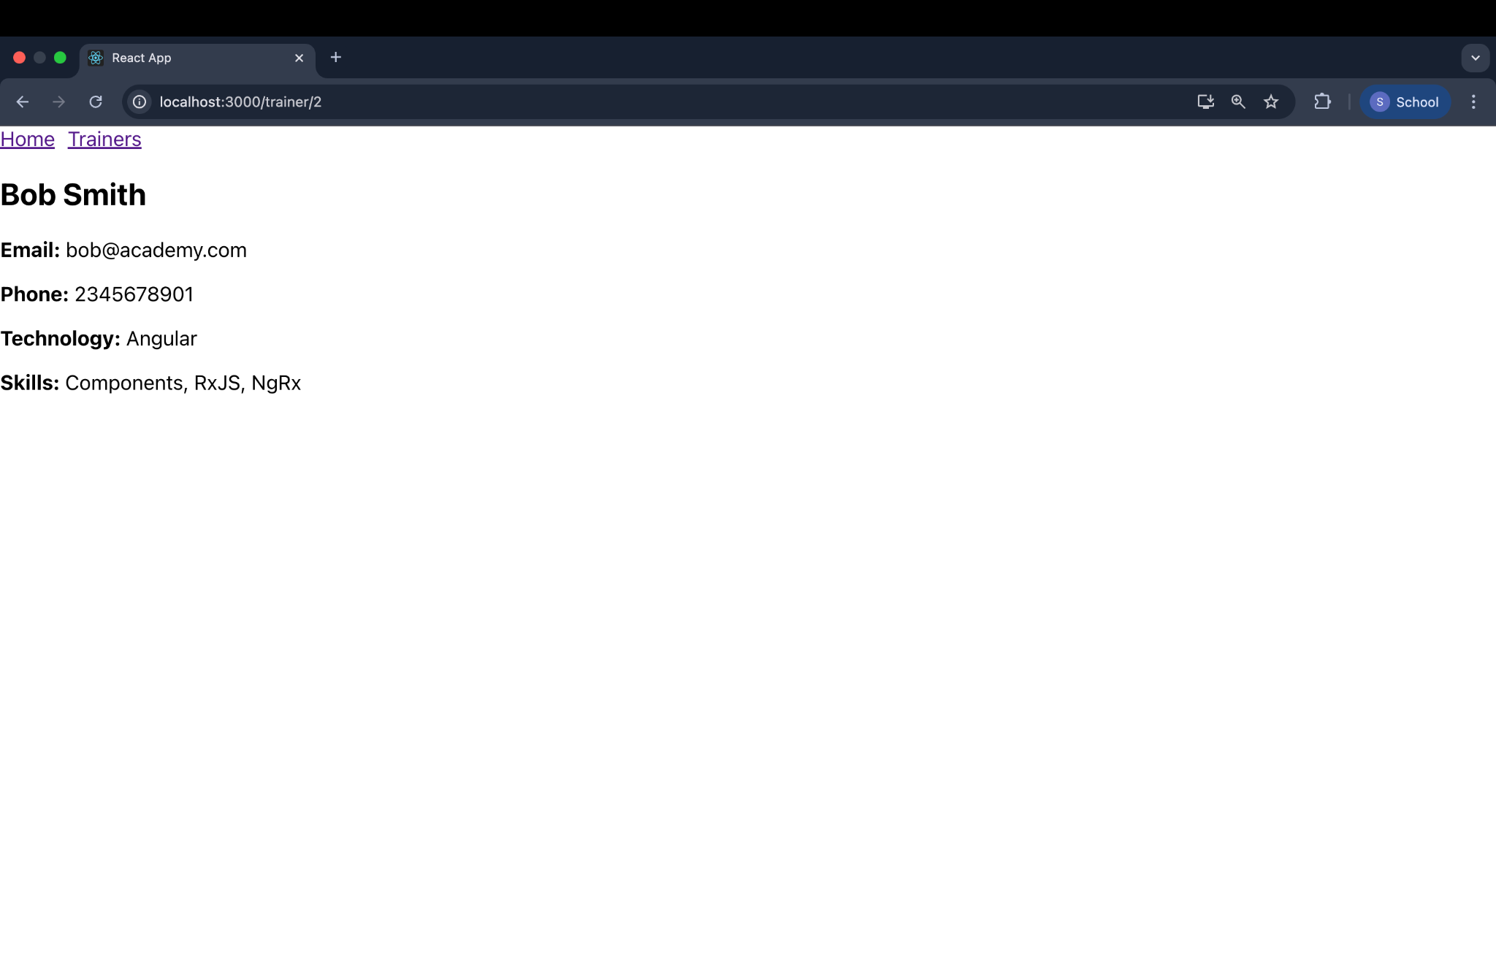

File 7. ReactJS-HOL
Cart.js
import React from 'react';
class Cart extends React.Component {
render() {
return (
<div style={{ border: '1px solid gray', padding: '10px', margin: '10px' }}>
<h3>Item: {this.props.Itemname}</h3>
<p>Price: ₹{this.props.Price}</p>
</div>
);
}
}
Cart.defaultProps = {
Itemname: "Unknown Item",
Price: 0
};
export default Cart;

OnlineShopping.js
import React from 'react';
import Cart from './Cart';
class OnlineShopping extends React.Component {
constructor(props) {
super(props);
this.items = [
{ Itemname: "Laptop", Price: 60000 },
{ Itemname: "Smartphone", Price: 25000 },
{ Itemname: "Headphones", Price: 2000 },
{ Itemname: "Keyboard", Price: 1500 },
{ Itemname: "Mouse", Price: 800 }
];
}
render() {
return (
<div>
<h2>Welcome to Online Shopping</h2>
{this.items.map((item, index) => (
<Cart key={index} Itemname={item.Itemname} Price={item.Price} />
))}
</div>
);
}
}

export default OnlineShopping;

App.js
import React from 'react';
import OnlineShopping from './OnlineShopping';

function App() {
return (
<div className="App">
<OnlineShopping />
</div>
);
}
export default App;

Output:
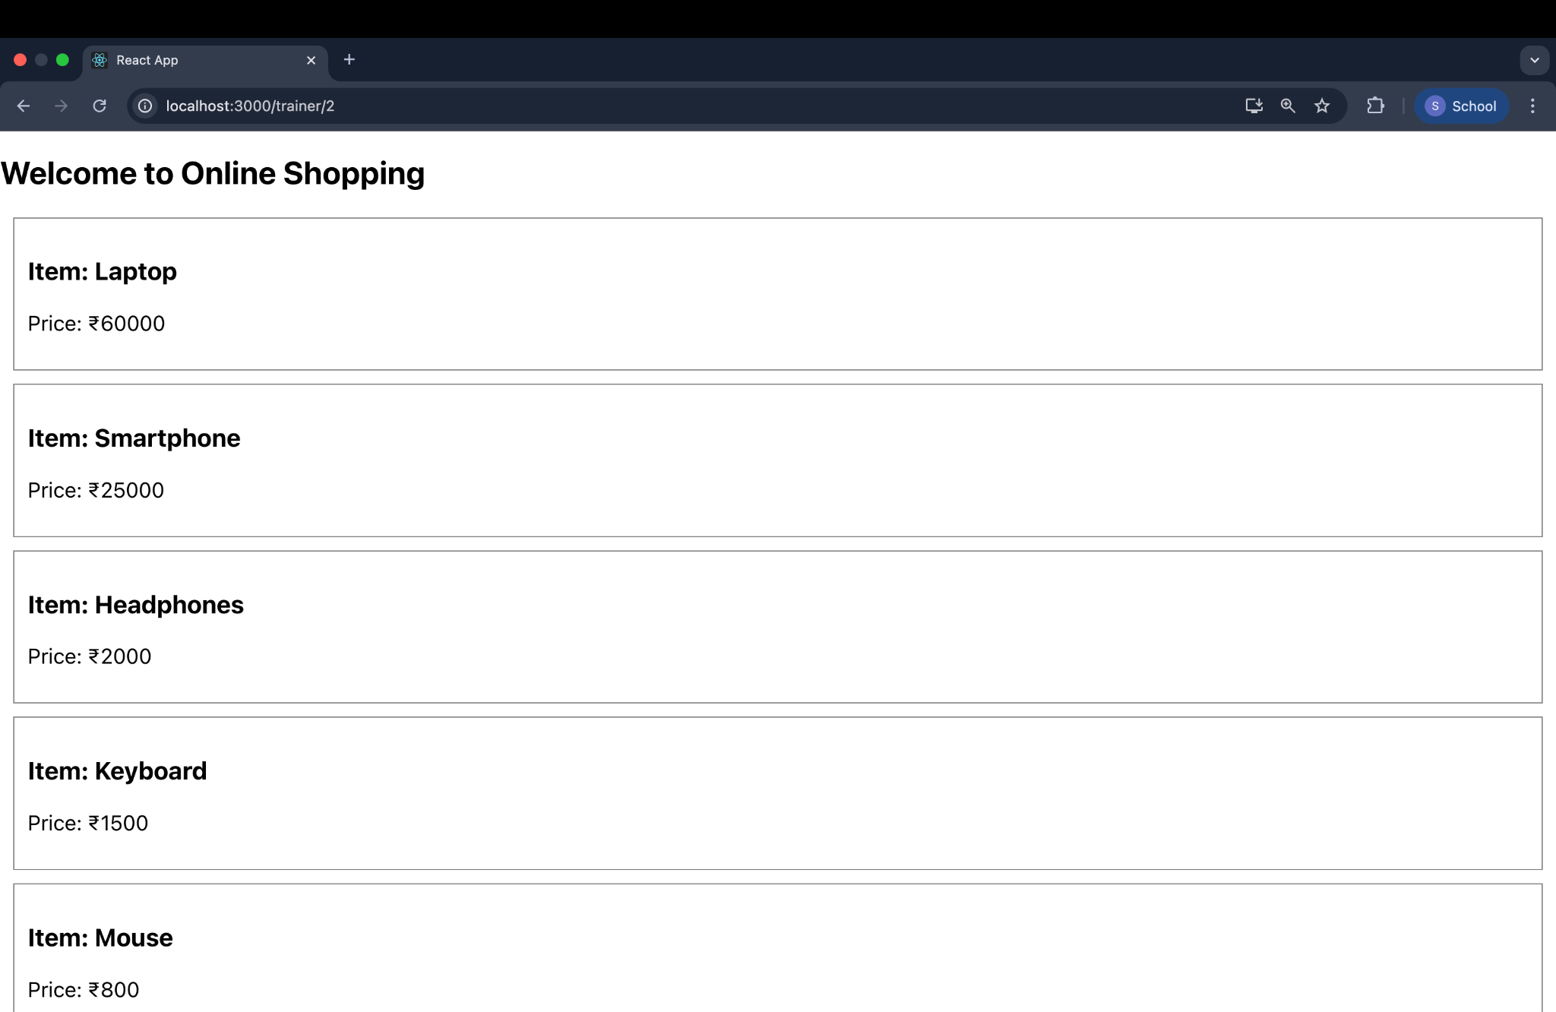

File 8.ReactJS-HOL
CountPeople.js
import React, { Component } from "react";
class CountPeople extends Component {
constructor(props) {
super(props);
this.state = {
entryCount: 0,
exitCount: 0
};
}
updateEntry = () => {
this.setState({ entryCount: this.state.entryCount + 1 });
};
updateExit = () => {
this.setState({ exitCount: this.state.exitCount + 1 });
};
render() {
return (
<div style={{ textAlign: "center", marginTop: "50px" }}>
<h1>Mall Counter</h1>
<p>People Entered: {this.state.entryCount}</p>
<p>People Exited: {this.state.exitCount}</p>
<button onClick={this.updateEntry}>Login</button>
<button onClick={this.updateExit} style={{ marginLeft: "10px" }}>Exit</button>
</div>
);
}
}
export default CountPeople;

App.js
import React from 'react';
import CountPeople from './CountPeople';
function App() {
return (
<div className="App">
<CountPeople />
</div>
);
}

export default App;

Output:
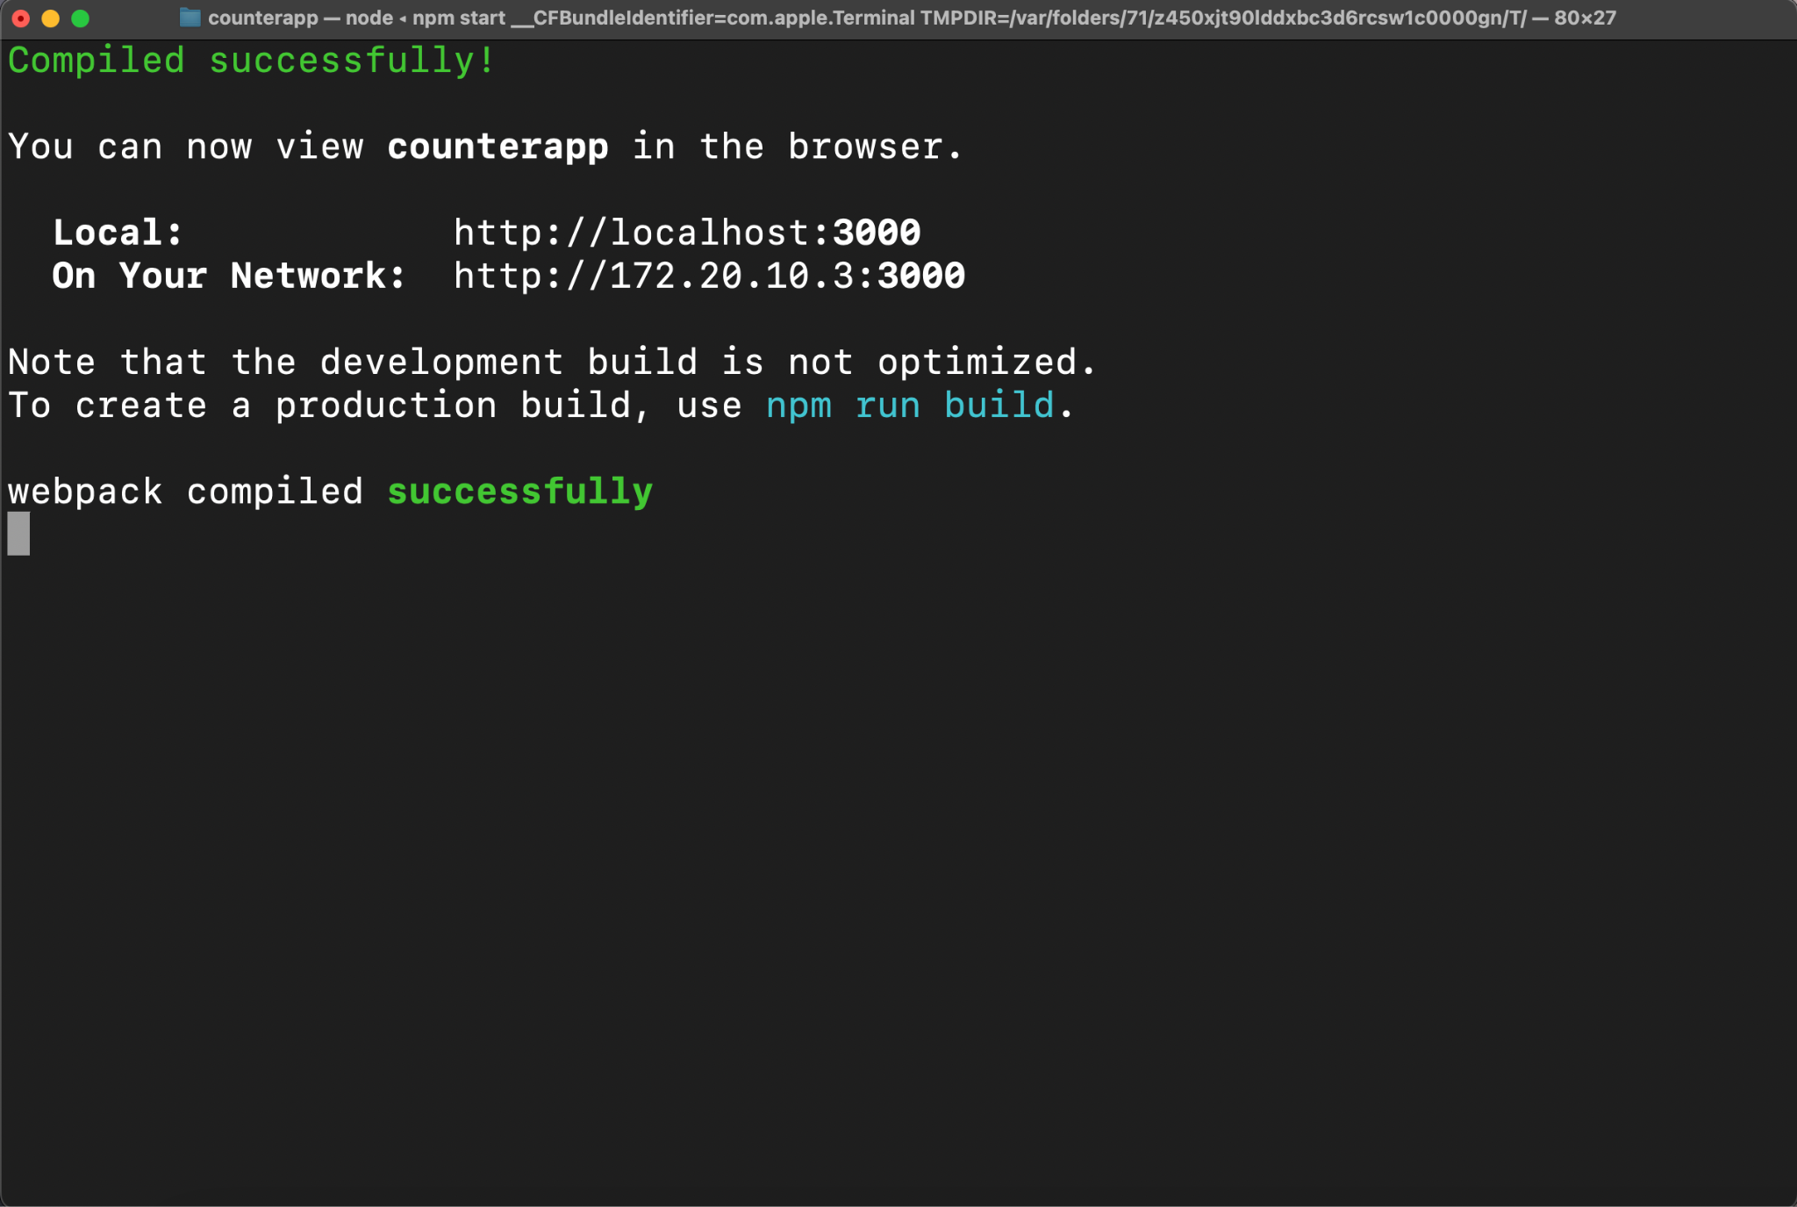

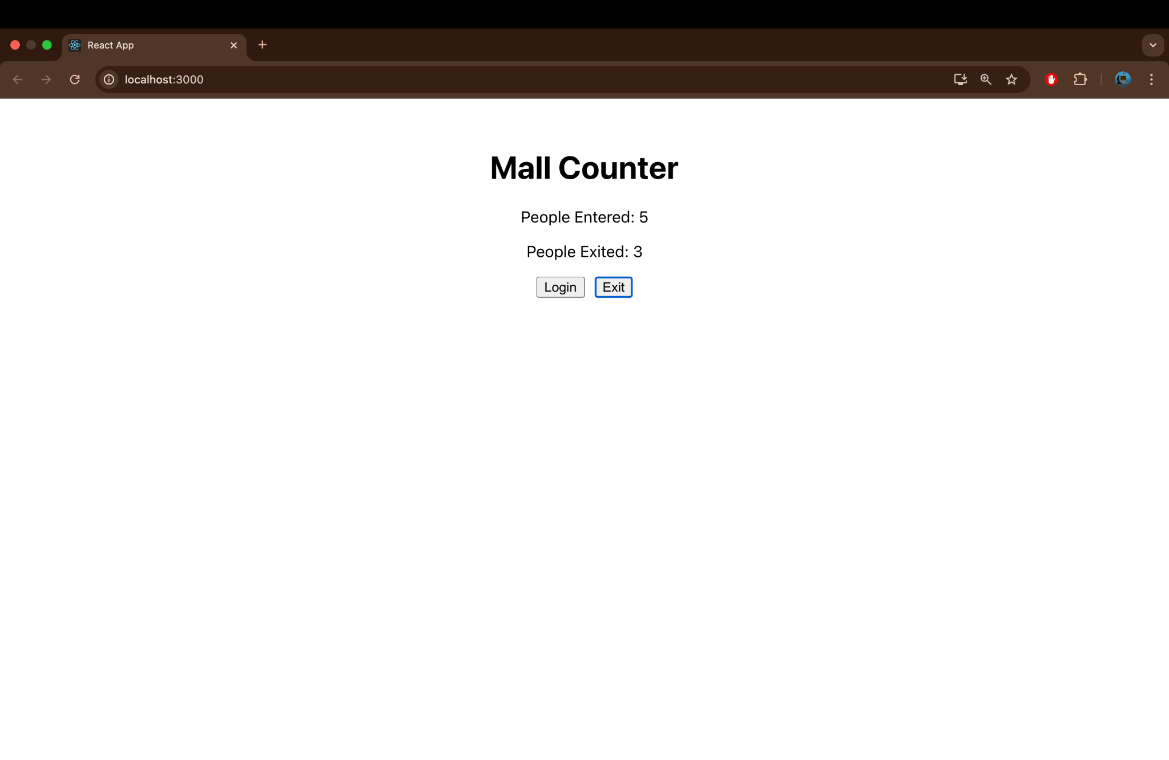

File 8. ReactJS Hands-on

ListofPlayers.js
import React from 'react';
const ListofPlayers = () => {
const players = [
{ name: "Virat", score: 90 },
{ name: "Rohit", score: 85 },
{ name: "Dhoni", score: 70 },
{ name: "Pant", score: 45 },
{ name: "Kohli", score: 60 },
{ name: "Rahul", score: 80 },
{ name: "Jadeja", score: 55 },
{ name: "Ashwin", score: 75 },
{ name: "Hardik", score: 40 },
{ name: "Shami", score: 65 },
{ name: "Bumrah", score: 50 }
];

const filteredPlayers = players.filter(player => player.score < 70);
return (
<div>
<h2>All Players</h2>
{players.map((player, index) => (
<p key={index}>{player.name} - {player.score}</p>
))}
<h2>Players with Score Below 70</h2>
{filteredPlayers.map((player, index) => (
<p key={index}>{player.name} - {player.score}</p>
))}
</div>
);
};

export default ListofPlayers;

IndianPlayers.js
import React from 'react';

const IndianPlayers = () => {
const oddTeam = ["Virat", "Dhoni", "Kohli", "Jadeja", "Hardik"];
const evenTeam = ["Rohit", "Pant", "Rahul", "Ashwin", "Bumrah", "Shami"];

const [virat, dhoni, ...others] = oddTeam;
const T20 = ["Gill", "Surya"];
const Ranji = ["Shreyas", "Prithvi"];
const merged = [...T20, ...Ranji];
return (
<div>
<h2>Odd Team Players</h2>
<ul>
{oddTeam.map((player, index) => <li key={index}>{player}</li>)}
</ul>
<h2>Even Team Players</h2>
<ul>
{evenTeam.map((player, index) => <li key={index}>{player}</li>)}
</ul>

<h2>Merged Team (T20 + Ranji)</h2>
<ul>
{merged.map((player, index) => <li key={index}>{player}</li>)}
</ul>
</div>
);
};
export default IndianPlayers;

App.js
import React from 'react';
import ListofPlayers from './ListofPlayers';
import IndianPlayers from './IndianPlayers';

function App() {
const flag = true; // Change to false to switch component
//2nd output for flag=false

return (
<div className="App">
<h1>Cricket App</h1>
{flag ? <ListofPlayers /> : <IndianPlayers />}
</div>
);
}

export default App;

Output:
